# APF Script

# Support Guide

Version No: 11.0

# Prepared by: Nikki Bromwich

# Date: 06 April 2012

Table of Contents

Purpose of the Document 3

APF Script Overview 3

APF Script Logic 3

APF Script Error Messages 4

General Errors 5

1. Please Sign In 5

2. Valid PNR not found 5

Name Screen Errors 6

3. Failed Private Fare Quote 6

4. Assign age Error 7

Flight Screen Errors 8

5. Failed to obtain Fare! 8

6. Failed Published Fare Quote 8

Quote and Confirm Screen Errors 9

7. Failed Private Fare Quote 9

8. AI / TC Error 9

9. NR Error 10

10. Credit Card Error 10

11. Net Fare Error 10

Support Log – Debug Log 11

# Purpose of the Document

This document is the support guide for the APF Script V11.0. It describes in detail the common errors experienced and the relevant trouble shooting steps.

# APF Script Overview

The APF Script automates the quoting and pre-ticketing process for Agency Private Fares by allowing the Travel Agent to manipulate the fare data according to special codes loaded into the OTHER NOTES section of the APF contract & also by information inputted by the agent, through the script itself. For a full description of the APF fields please refer to the APF Script Fare Loading guide.

# APF Script Logic

The script creates a manual filed fare by completing the following steps. Understanding this logic will assist you in troubleshooting the script.

1. Quotes the APF fare (FQ….)
   1. Using the passengers selected on the Name Screen
   2. Using the fare quote modifiers selected on the Flight Screen
2. Reads the OTHER NOTES field of the APF fare (FQN, followed by FN1)
3. Ignores and retrieve (IR)
4. Quotes the APF fare again (FQ….)
5. Displays the filed fare (*FF1)
6. Cancels the APF fare (FX1)
7. Quotes the Published fare (FQ@....:N)
   1. Using the fare basis from the PFBC field of the APF contract
8. Cancels the published fare (FX1)
9. Quotes the APF fare again (FQ….)
10. Deletes the tour code (TMU1TC@)
11. Adds the car code (TMU1AI-….)
12. Adds the form of payment and net fare amount (TMU1F…./NF….)
13. Converts fare to a manual fare build (*FB1)
14. Updates the fare and fare calculation line (FBUFARE/….+EQ/….+TTL/+FC/….+FB1/….+FB2/….)
    1. Using the value from the published fare
    2. Using the data from the FC1-FC3 lines in the APF contract)
    3. Using the data from the TFBC field for the FB1 / FB2 etc)
    4. Using the data from the APF contract for the FB1 / FB2 if no TFBC has been filed)
15. Updates the endorsement field (FBUEB/….)
16. Files the fare (FBFALL)
17. Recieves the PNR (R.APF/P)
18. End and Recieves (ER)

# APF Script Error Messages

There are 2 types of errors found in the APF Script:

* **Script Errors** – which display in a pop up box. These are normally a result of missing data.

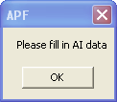 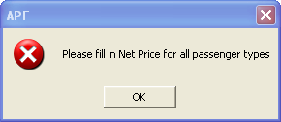

These are fixed within the script itself, by following the instructions in red.

* **Host Errors** – which display in a pop-up box. These occur if the host can not perform the relevant entry.

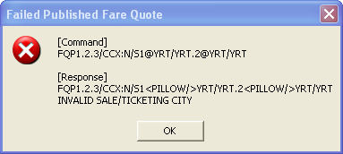

Please Note: Below you find a list of the common errors and the troubleshooting steps to address these, however these are not all errors returned by the script. If an error is returned and you can not determine how or why please refer to the *debug log*.

This log records all host entries and responses performed by the script (full details on P13 of this guide).

# General Errors

## Please Sign In

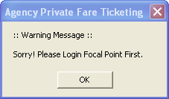

This message is displayed if the user is not signed into Galileo Desktop and clicks on the Custom Viewpoint toolbar APF script icon to initiate the script.

Click “**OK**” to close the error window and then

* Sign into Galileo Desktop
* Retrieve the PNR
* Then click on the APF script icon to run the script again.

## Valid PNR not found

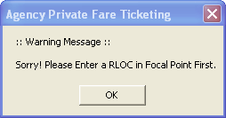

This message is displayed when the agent clicks on the Custom Viewpoint toolbar APF script icon to initiate the script however an active PNR/Booking file is not present.

Click “**OK**” to close the error window and then

* Retrieve a PNR
* Then click on the APF script icon to run the script again.

# Name Screen Errors

## Failed Private Fare Quote

This error was not returned until the agent clicked Press Here <<Start to Quote>> on the Quote and Confirm Screen.

Click **OK**

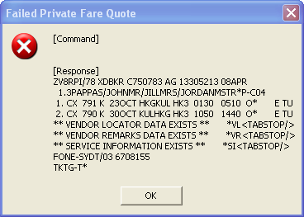

Click **<< Back**

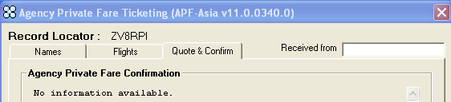

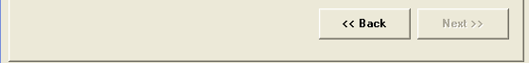

Click on the **Names** TAB

Select at least 1 passenger to continue.

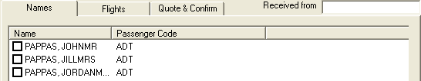

## Assign age Error

This error was not returned until the agent clicked Press Here <<Start to Quote>> on the Quote and Confirm Screen.

Click **OK**

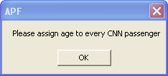

Add age to the CNN fare

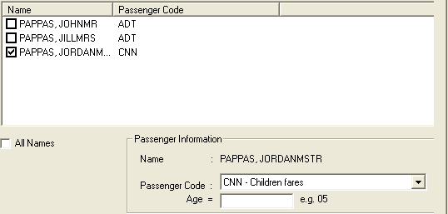

# Flight Screen Errors

## Failed to obtain Fare!

Cause: The script is unable to quote the private fare with the details provided

Click **OK**

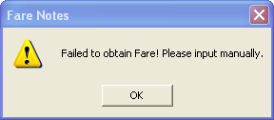

Add an account code and/or segment select if required

## Failed Published Fare Quote

This error was not returned until the agent clicked **<<Next** on the Payment Screen.

Cause: Agent has added 2 fare basis’ into the published fare basis field of the “Flights” screen

Click **OK**



Click **<< Back**





Update the Published Fare Basis to reflect 1 fare basis only

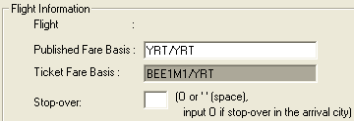 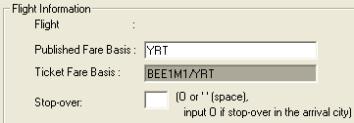

# Quote and Confirm Screen Errors

## Failed Private Fare Quote

Cause: Agent has removed the account code from the quote and confirm screen

Click **OK**

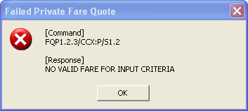

Click **<< Back**





Add the account code to the Private Fares Information – Account field.

## AI / TC Error

Cause: The agent has selected AI / AI + VC field in the Nett Remittance field of the Quote and Confirm screen.

Click **OK**

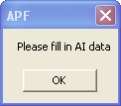

Add details into the AI field.

## NR Error

The error did not occur until the agent clicked on **<Confirm>** on the Quote and Confirm screen.

Cause: The agent has selected the NR modifier, along invoice form of payment.

Click **OK**

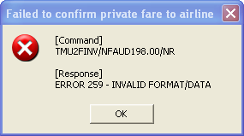

Click Back, then change the FOP or click Back and update the NR field.

## Credit Card Error

Cause: The agent has selected credit card form of payment but has not added credit card details

Click **OK**

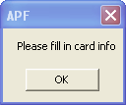

Add credit card details

## Net Fare Error

Cause: The agent has removed the Net Fare amount from the Net Fare field.

Click **OK**

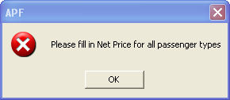

Update the net fare amount.

# Support Log – Debug Log

The debug log is used for trouble shooting as it shows a list of all entries performed by the script and the host response returned. It is opened as notepad file.

The log is created as part of the installation and by default is found in the following path.





By reviewing the debug log you can determine why the script failed if you are not familiar with the error returned by the script.

